Week 10: Digital to Physical

## Chosen game (Tetris)

The game chosen by the team to make into a board game is Tetris. The name for the board game is called “Tetris: But on a board”. Tetris is a strategic based game which relies on people to move differently shaped pieces which descend onto a playing field. Players fill in missing spaces on the board which will allow them to create lines. Once a player completes a set of lines, they are awarded points. The player with the most points wins. The method for our game is ‘literal-based’. This means that the exact gameplay method, design and rules are lifted from the digital game into the board game; aside from the scoring aspect.

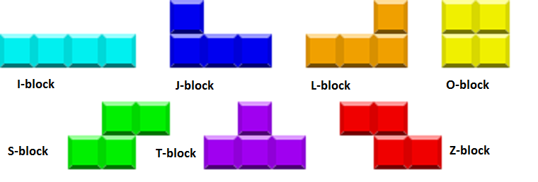

Figure 1: 7 pieces used in the game

## Functionality

The board for the game will be similar to that of 4-in-a-row. Players will drop their pieces from the top and land at the bottom. The idea for our board will be that players are able to push out the blocks from the side which will exit from the other end. This allows the board game to have the same effect as lines being cleared from the actual game.

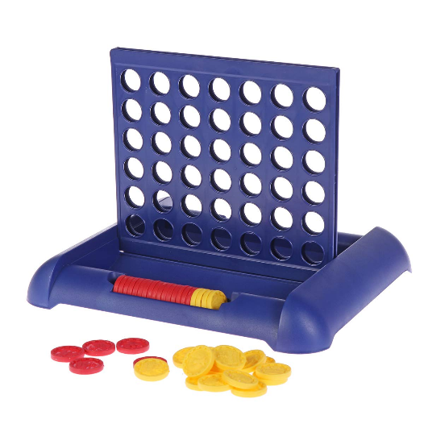

Arrow signifying where players can push out blocks to the opposite side of the board.

Figure 2: Using a similar board from the game 4-in-a-row

The pieces are made of individual small squares. For example, 4 small squares make up a single block. After the player has pushed out the blocks out from the other side, the squares can be collected and reassembled into the blocks again. This idea helps by recycling used material and be able to reuse them in the game.



Figure 2.1: Example of the O block piece

## Materials

* Playing board
* Timer
* Individual small squares
* Spinning wheel

## Goals

The goal of the game is to get more Tetrises compared to the opponent in the set time to win. If the player is playing alone, they can either time themselves to see how many Tetrises they can achieve before time runs out or how many they can get before topping out.

## Mechanics

There will be a spinning wheel that decides the order in which players can use the next block.

## Rules

Players may only “hold” or “keep” a block once per turn. This means that they are unable to constantly switch between blocks until they get a block they prefer.

## Example and Explanation of gameplay

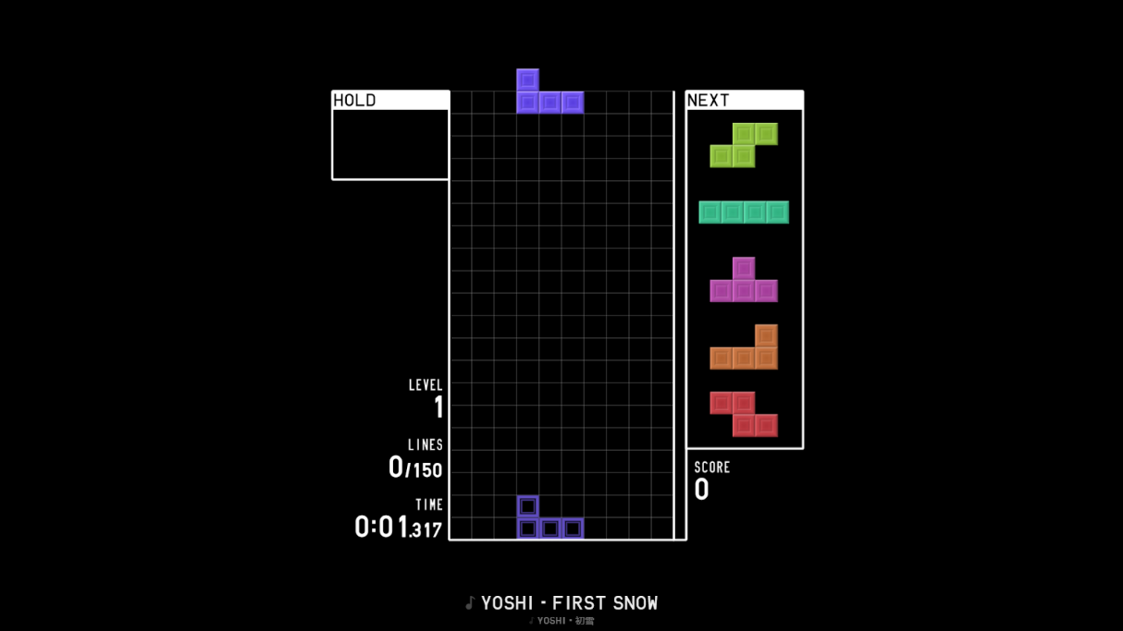

Figure 3: Board showing the Tetris game from the Tetr.io website/application

A visualisation of how the actual Tetris board looks like from the above figure. It is a 20 by 10 blocks in terms of height and length. The box at the top left signifies the “HOLD” box; gives players the option to keep an unwanted block. The boxes on the right indicates which blocks are coming next for the players to use.

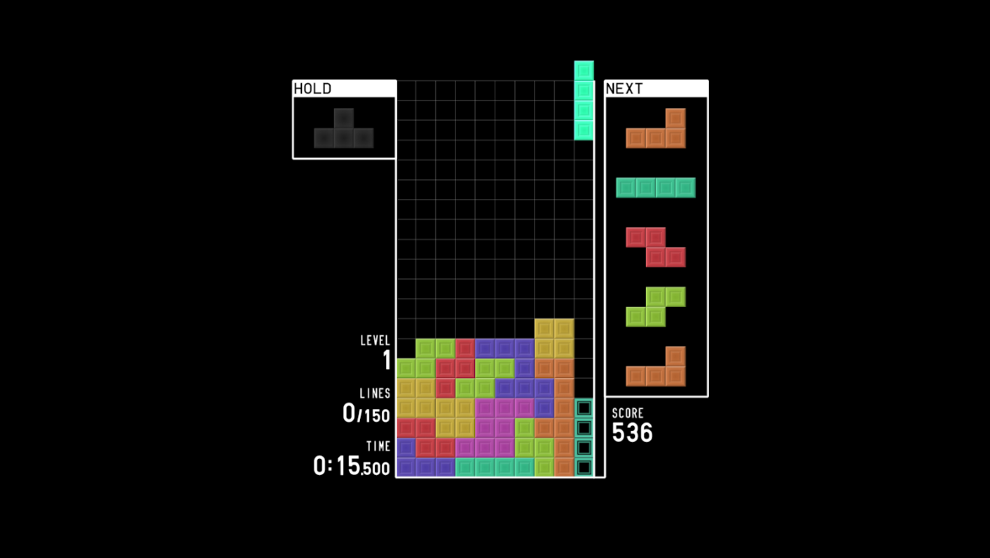

Figure 3.1: Board showing the player ready to achieve a ‘Tetris’

The figure above shows an example of what a representation of the game on a board would look like. Players stack as high as they wish and once, they have an “I-piece”, they can drop it down on the 1-wide game on the far right. By doing this, players have achieved a Tetris and gain 1 point.

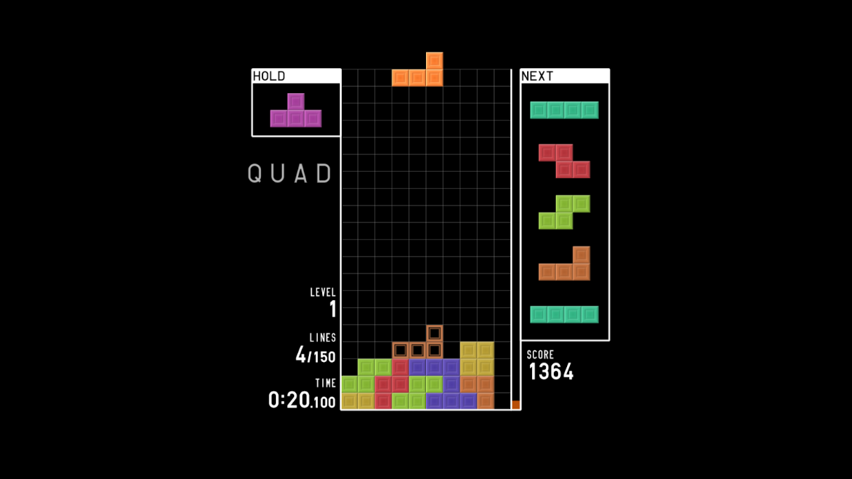

Figure 3.2: Board showing the player has cleared 4 lines by inserting the I-piece in the 1-wide gap

Above shows what happens after you clear 4 lines (Tetris). After achieving this, players will need to stack up again to get another Tetris clear.

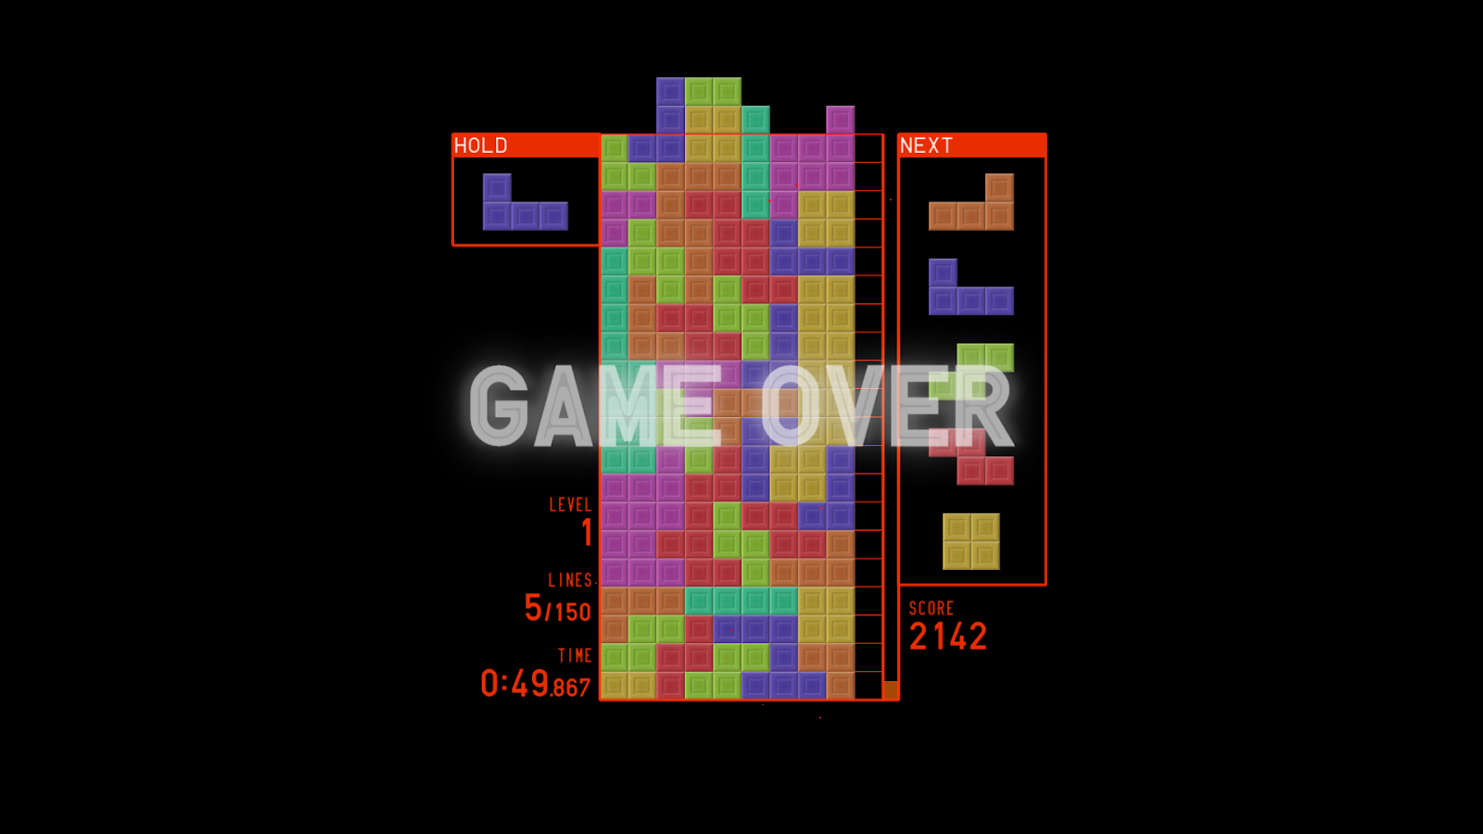

Figure 3.3: Board showing how a player loses by over-stacking

If players over-stack, they will top out and lose. This also applies to the board game, if players fail to keep a clean and consistent board.

## Play testing

Only internal playtesting was carried by the team due to the lack of members and time. The team tested out the ideas by using the actual application demonstrated by a member of the team. In the end, it was decided that the idea will work out and there are no flaws with the idea.

## Improvements and Reflections

At the moment, players must have more Tetrises compared to the opponent to win the game. An addition to add would be a scoring system. Therefore, there will be 2 ways in which players can win the game instead of just having one way.